Nama : Nafizhar Rayhansyah

NIM : 1202220232

Kelas : SI4605

1. Instal Laravel

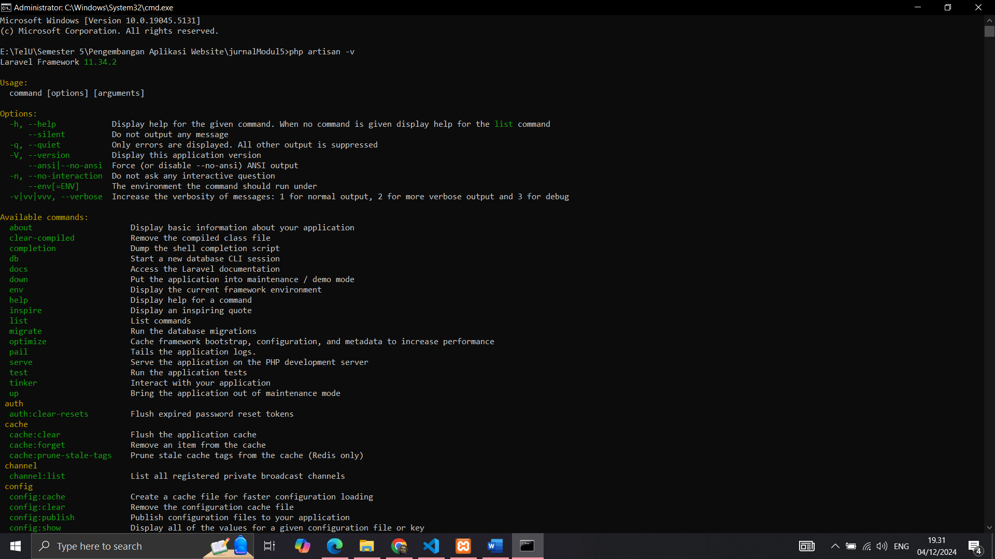

1. Membuat Database dan Tabel

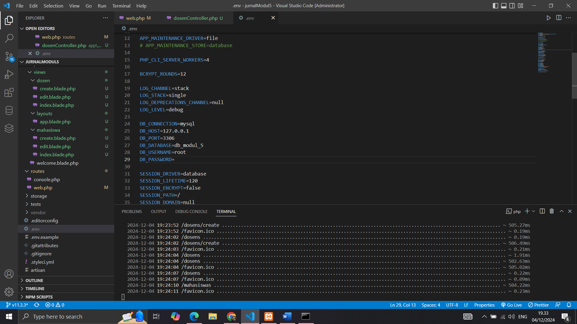

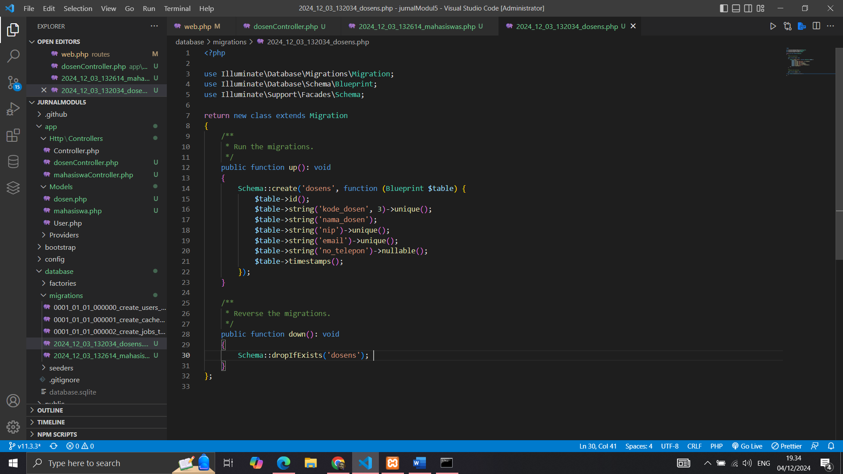

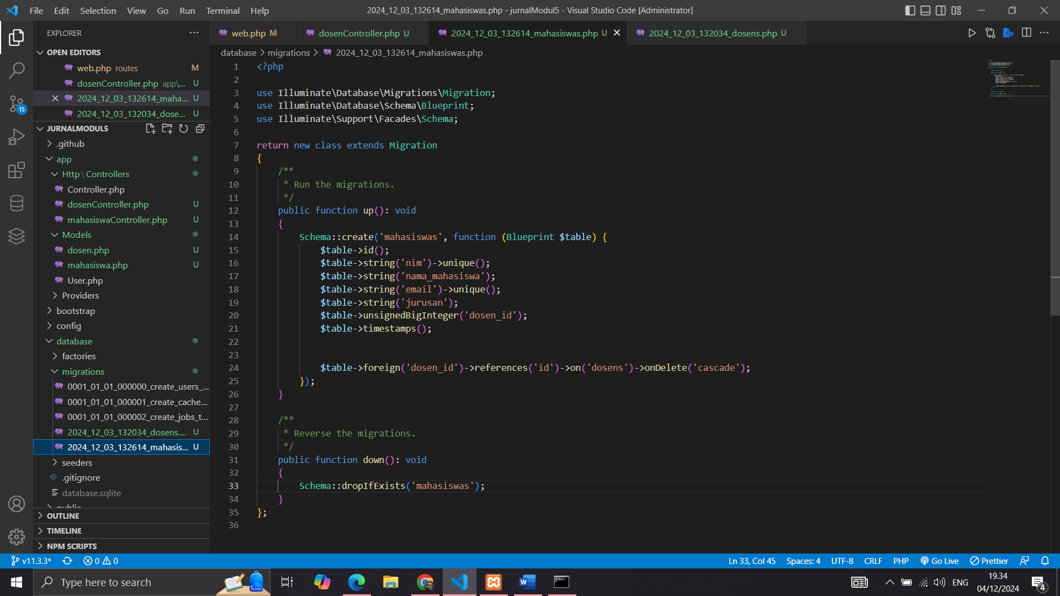

1. Membuat Model

1. Menambahkan Fungsi CRUD di Controller

1. Membuat View

1. Menambahkan Routing

1. Menjalankan Aplikasi

